Solar Seaweather & Pollution Transmitter Buoy

Unlike weather on land, seaweather is highly unpredictable and changes drastically at times. Keeping track of sea weather at all times is a very tough task. Also sea pollution is a growing issue of concern and the first step to controlling pollution is measuring it. Another problem is the unavailability of cellular or other data networks in sea or data transmission. It is necessary to use small seaweather stations with own data transmission capability in the sea at all times to get data about these details.
So we hereby design and develop a small seaweather as well as sea pollution monitoring station that can transmit this data over to the monitoring station on sea shores. The system uses a range of sensors all controlled by an STM32 controller in order to achieve this task. Along with it we also develop a receiver system to receive and display the data from the transmitter.
The transmitter unit is always in the sea and its not possible to constantly charge itself from time to time, so we use a solar panel to allow it to generate its own power and keep working in the sea. The solar panel charges the onboard battery which is used to power the circuitry.
The transmitter uses ph sensor to measure ph level of water, turbidity to check pollution, temperature of water and humidity above the water. Also the system has an accelerometer to detect sea state, depending on weather the sea is rough or calm, the accelerometer throws values that can be used to check if sea is calm or rough.
These values are constantly monitored by the stm32 controller and transmitted at certain intervals by through a rf transmitter. The transmitter is fitted with a high gain antenna in order to achieve maximum transmission range.
Now the receiver unit is developed using a n atmega microcontroller and display in order to receive data transmitted by the transmitter buoy and display it. The receiver unit consists of a rf receiver with antenna that is used to receive the data values transmitted by sea unit.
This data is now received and processed by the atmega microcontroller. The microcontroller now displays these values on the LCD display. If a value is not normal or beyond set range it also sounds a buzzer alert and displays alert in order to notify station officers to take action and warn ships/people in the vicinity.

Components
- Stm32 Controller
- Atmega328 Controller
- LCD Display
- Solar Panel
- Battery
- PH Sensor
- Turbidity Sensor
- Temperature Sensor
- Humidity Sensor
- Accelerometer
- LCD Display
- RF Transmitter
- RF Receiver
- Antennas
- Buzzer
- LED’s
- PCB Board
- Resistors
- Capacitors
- Transistors
- Cables and Connectors
- Buoy Body Frame

Block Diagram
Transmitter Unit
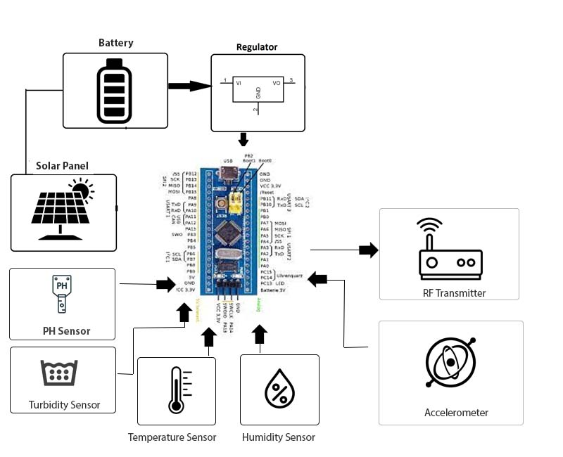

Receiver Unit
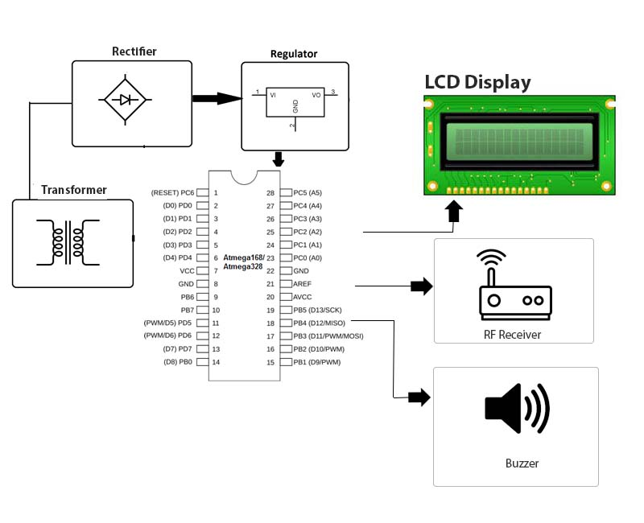

Block Diagrams
